**Database and Management System Lab**

NAME: PRIYANSHI VARSHNEY

ROLL NO: R2142230042

SAP_ID: 500119947

BATCH 2

B.TECH CSE, SEM-III

**EXPERIMENT 8**

**Title: Use of different SQL clauses and join**

**Objective:** To understand the use of group by and having clause and execute the

SQL commands using JOIN

**1. Consider the following schema:**

**Student (sid, sname, age)**

**Match (mid, mname, venue)**

**Play (sid, mid, day(date))**

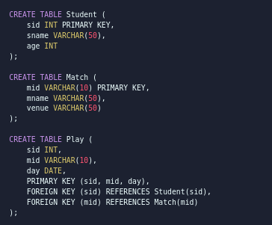

**2. Populate all the tables.**

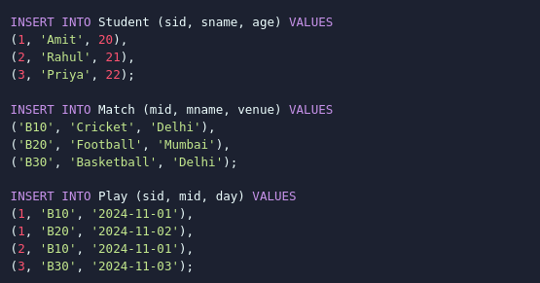

**3. Find all information of students who have played match number B10.**



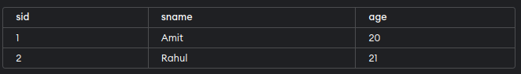

**4. Find the name of matches played by Amit.**

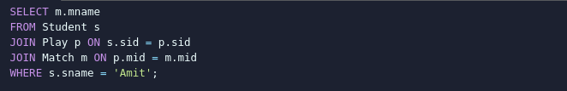

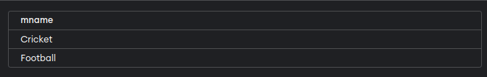

**5. Find the names of students who have played a match in Delhi.**

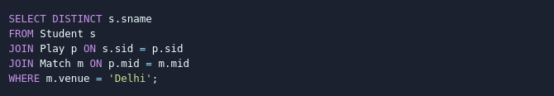

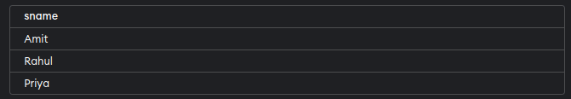

**6. Find the names of students who have played at least one match.**



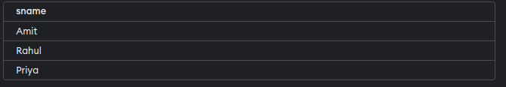

**7. Find the ids and names of students who have played two different matches on the same day.**

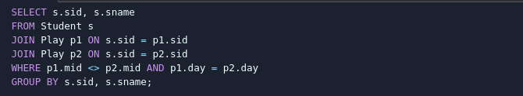



**8. Find the ids of students who have played a match in Delhi or Mumbai.**

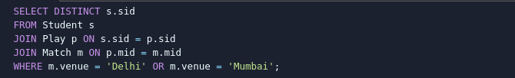

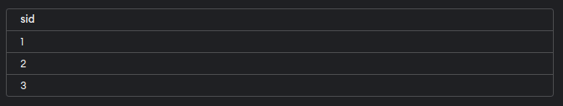

**9. Find the average age of students.**



